- Diagram
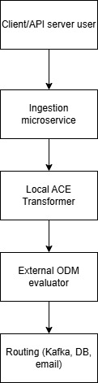

2. Component responsibilities
Component | Responsibility
Ingestion API | Accept file, parse content, coordinate processing
ACE Transformer | Simulate IBM ACE
ODM Evaluator | Stub of external rule engine like IBM ODM
Router | Directy data to Kafka, DB or email, based on rule decision

3. Scaling and Fault Tolerance
- Scalability:
- Can run behind a load balancer
- Kubernetes / ECS

- Failure handling:
- Retry logic via async message queue as kafka or aws sqs
- Can persist failed request for processing (dead-letter queue simulation

4. Future Extensibility
- Smart routing with AI: Replace DecisionServiceClient logic with ML model
- Audit and Metrics: Add sidecar for telemetry (Prometheus/Grafana)

5. Bonus
- Interfaces have been implemented on the 3 services
- Retry: failed routing jobs can be pushed to Kafka/SQS, and a background job will retry those jobs asynchronously

